**CREATING A PIPELINE IN APACHE AIRFLOW**

**Theophila Murphy S**

**DE-Batch 6**

**Creating A Pipeline In Apache Airflow**

**Step 1: Open Airflow Web UI**

• Open your browser and navigate to: http://localhost:8080

• The Airflow home page will open.

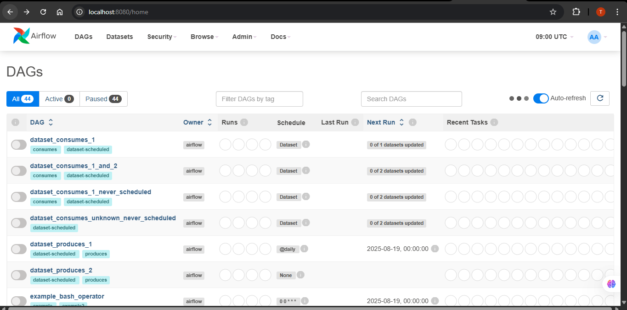

**Step 2:** Click on **Admin** in the top navigation bar

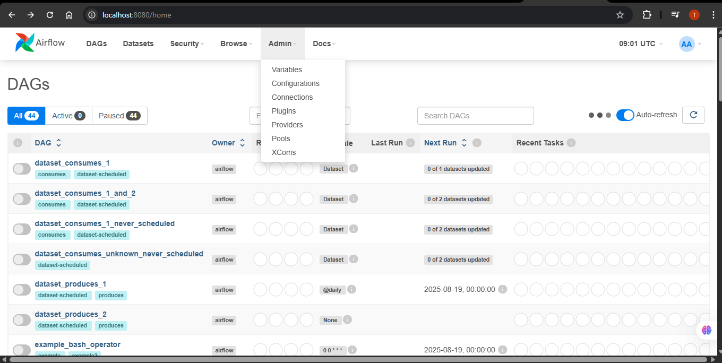

**Step 3: Open Connections**

• Under the **Admin** menu, click on **Connections**.

* Click the **+ (Add a new record)** button.

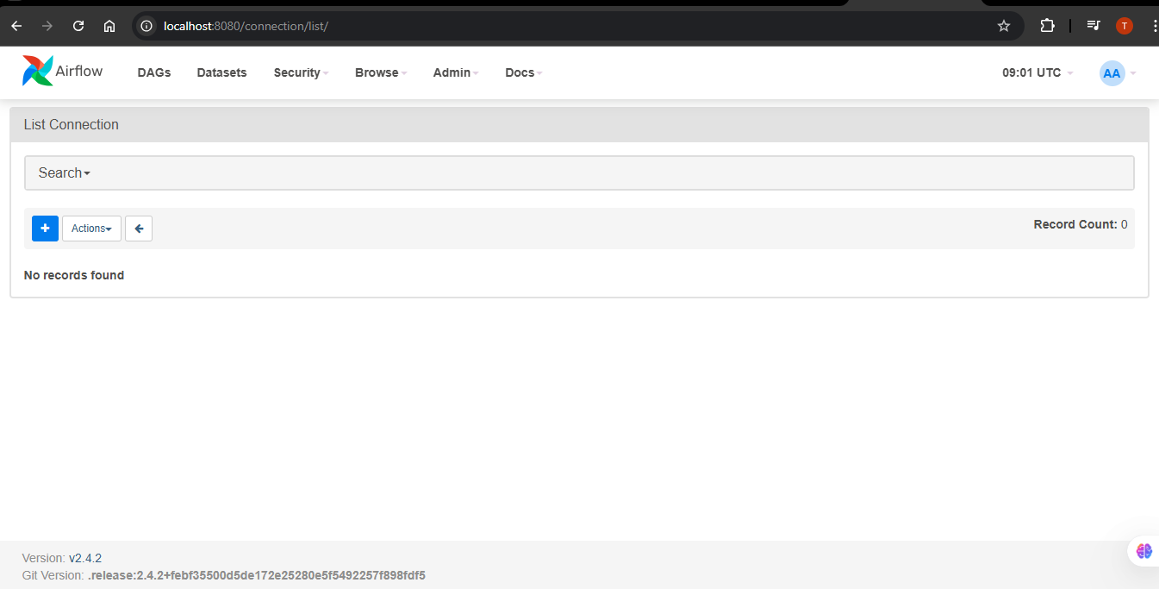

**Step 4: Add New Postgres Connection**

Fill in the details as below:

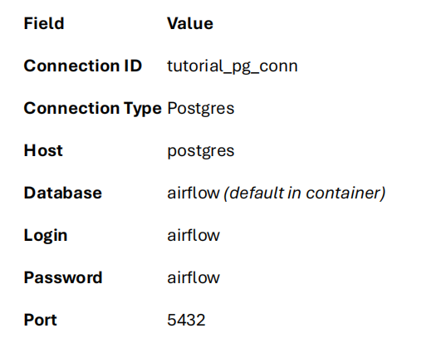

* Click **Save**

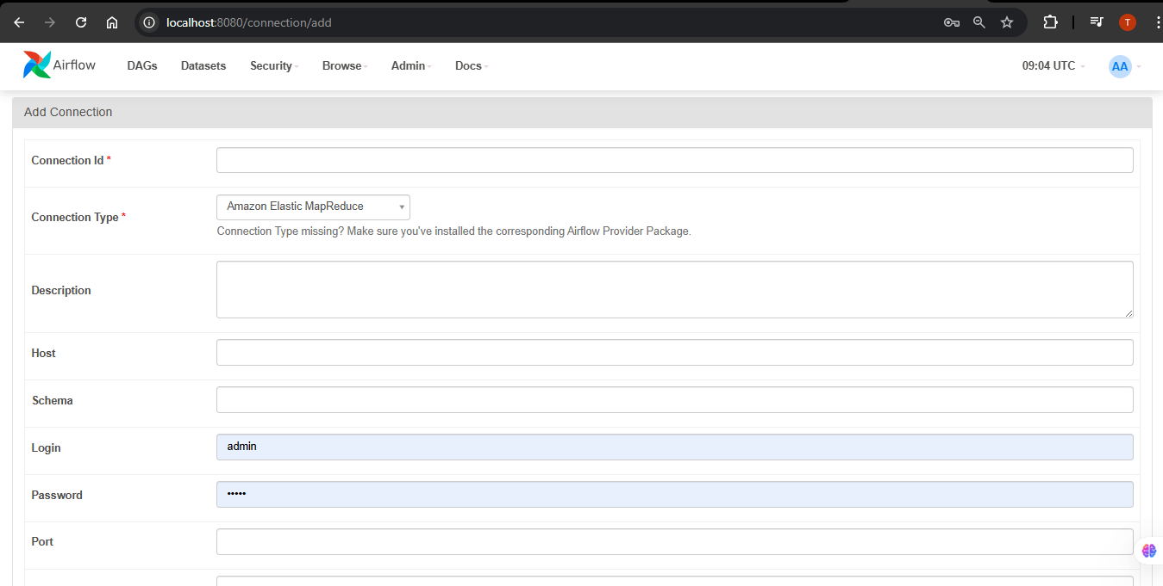

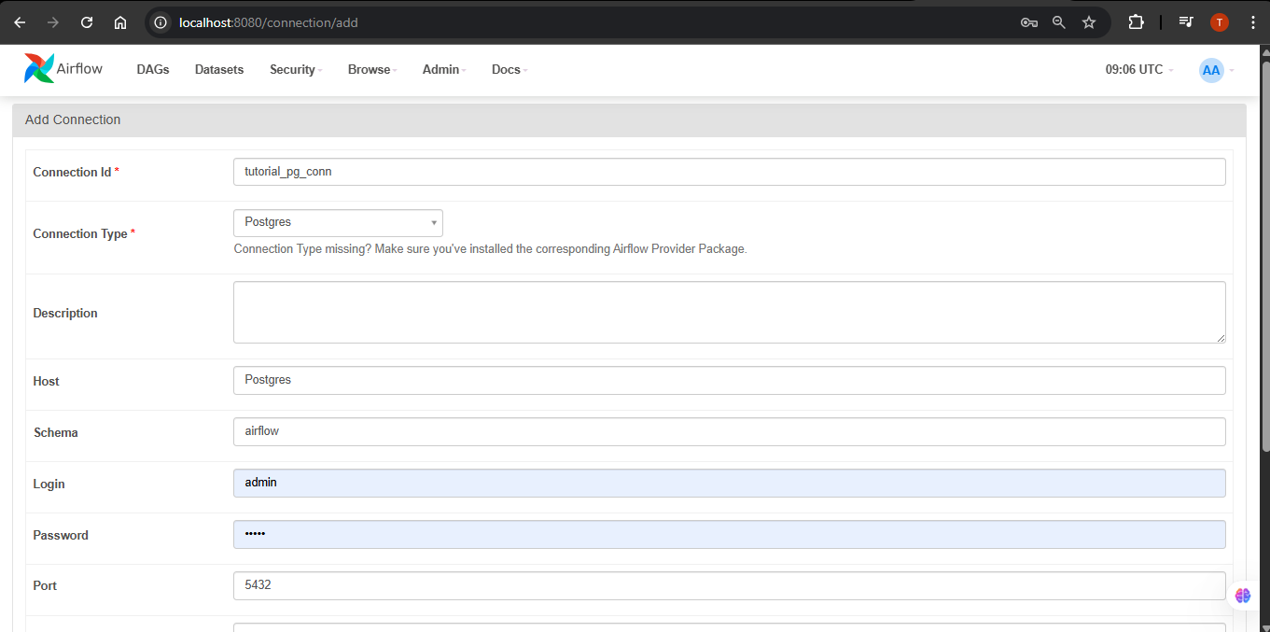

**Step 5: Connection Added**

**•** The new connection **tutorial_pg_conn** is now listed under Connections.

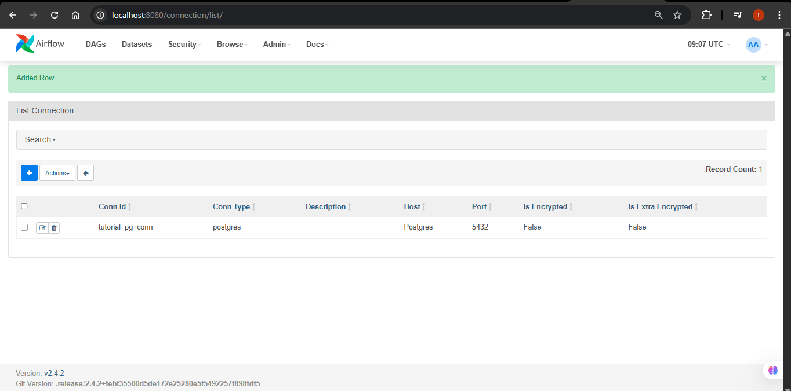

**Step 6: DAG Created**

• Open the Airflow UI (localhost:8080).

• In the **DAGs list**, you will now see **process_employee** listed

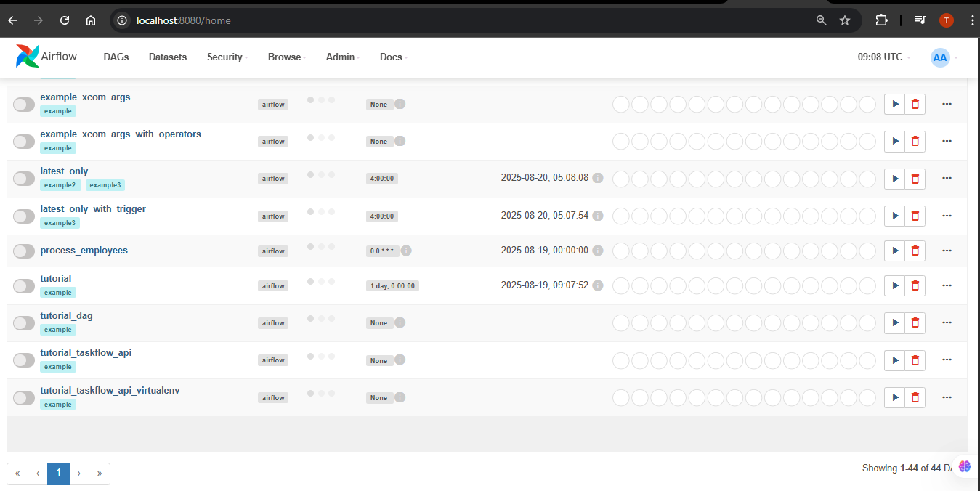

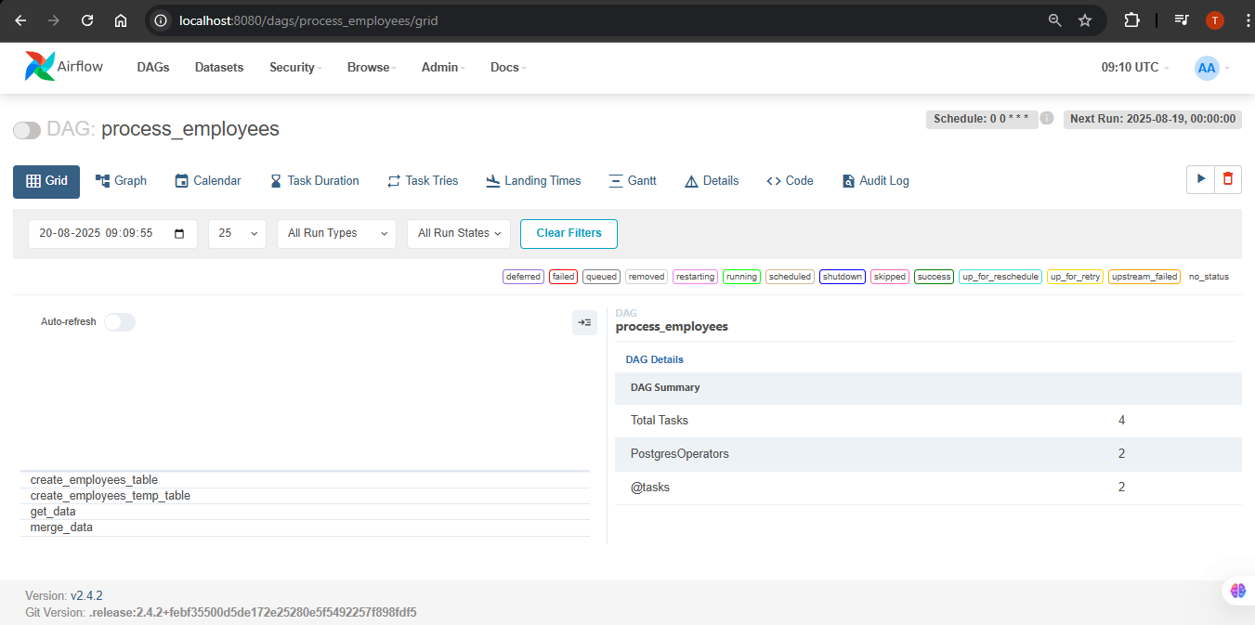

**Step 7: Trigger the DAG**

• On the right side of the **process_employee DAG**, click on the **Trigger DAG**

button.

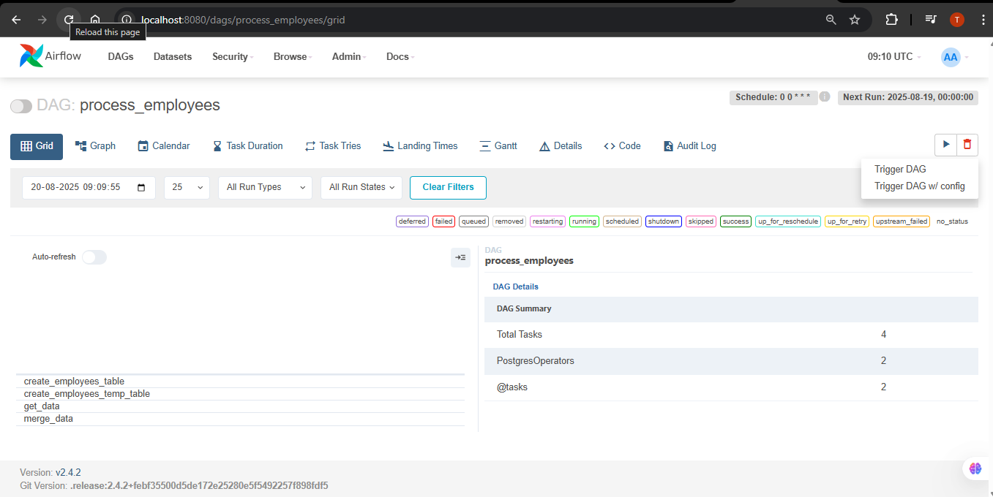

**Step 8: DAG Started**

• The DAG will start running.

• You can see the status of each task in the **Graph view** or **Tree view**.

***Grid View:***

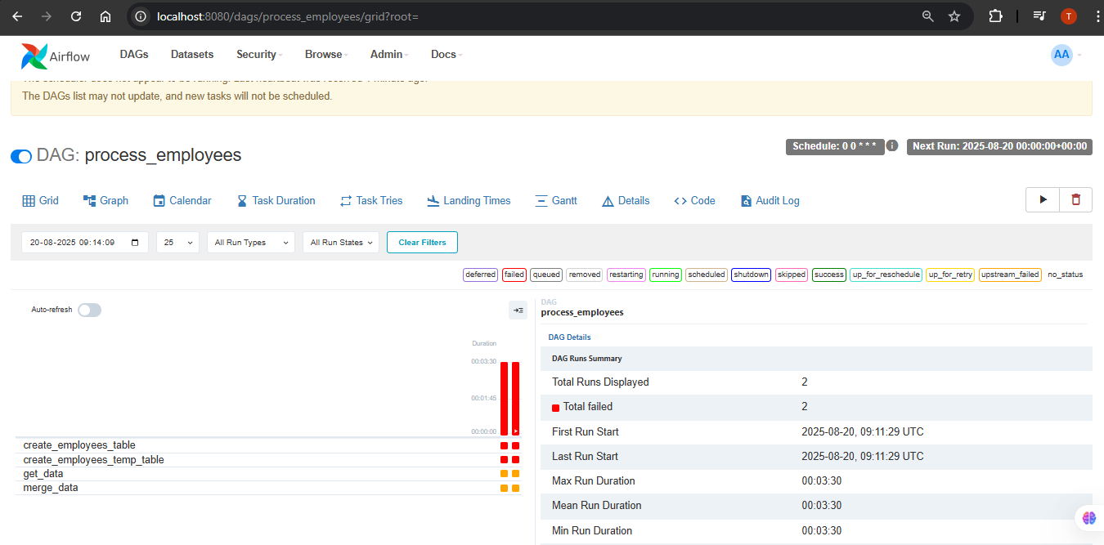

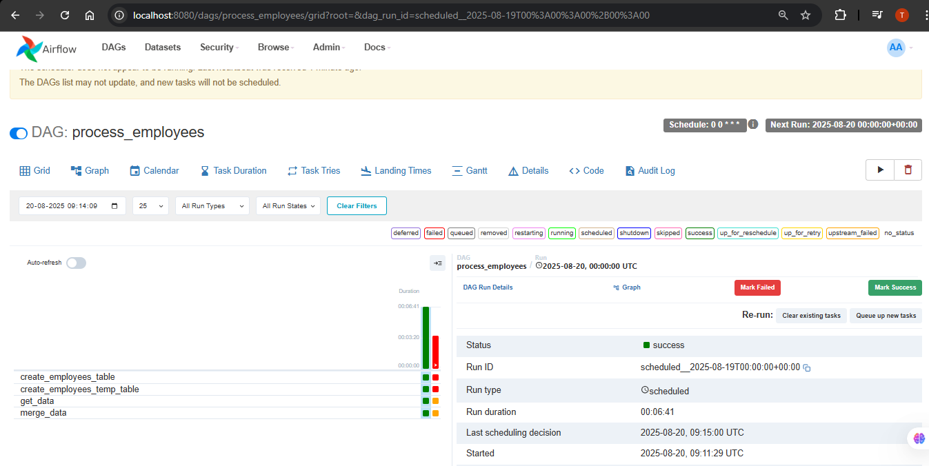

***Graph View:***

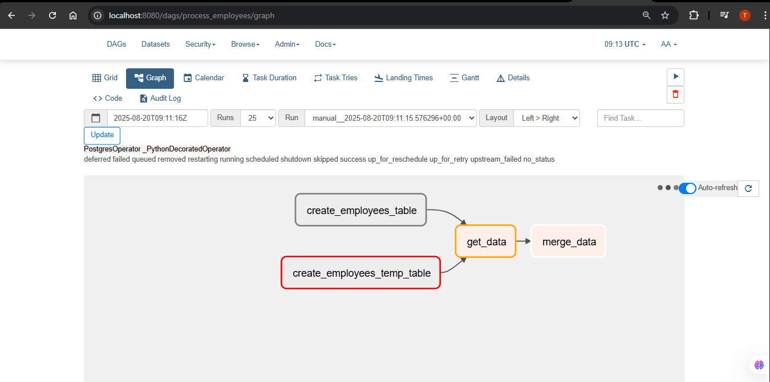

***Calender View:***

